



Business Requirement Document
Supply Chain Management
NWS Movement Request Integration (Inbound & Outbound)
DOCUMENT FOR

Table of Contents:
Table of Contents: 1
1. Introduction 2
1.1 Business Need 2
1.2 Expected Business Outcomes 2
1.3 Project Scope Summary 2
2. Business Requirement Details 3
2.1 Requirement Description 3
2.2 Functional Requirements 3
2.3 Non-Functional Requirements 4
3. System Integration 5
4. Data Mapping Fields 5
5. Process Flow 6
6. Assumptions & Constraints 7
7. Risks & Mitigation 8
8. Open and Close Issues 9
8.1 Open Issues 9
8.2 Closed Issues 9

Introduction

1.1 Business Need
Nama Water Services currently manages material movements and inventory transactions in both Hexagon EAM and Oracle Fusion Inventory Management. Currently, Movement Requests and Material Issue transactions in Hexagon EAM are Automatically reprocessed in EBS. Nama Water Services requires same automated integration between Hexagon EAM and Oracle Fusion Inventory.

1.2 Expected Business Outcomes
- Seamless automation of Movement Request Issue transactions from Hexagon to Oracle Fusion.
- Ensure only approved transactions from Hexagon are posted in Fusion.
- Synchronization of inventory balances and movement request statuses between both systems.
- Enhanced visibility of on-hand quantities and request status in both applications.
- Reduction of manual intervention and improved operational efficiency.
- Strengthened traceability through complete audit trail of integrated transactions.

1.3 Project Scope Summary
The project scope includes two-way integration between Hexagon EAM and Oracle Fusion Inventory:
- Inbound Integration (Hexagon → Fusion): To create Movement Request Issue transactions in Oracle Fusion.
- Outbound Integration (Fusion → Hexagon): To share Inventory On-hand details, Movement Request Status, Inventory Org, and Sub-inventory list.
Integration will be facilitated through Oracle Integration Cloud (OIC) or SOA with secure APIs, real-time status tracking, and error handling.

Business Requirement Details

2.1 Requirement Description
A Movement Request (MR) is created in Hexagon EAM when a user requests material for a specific task or maintenance activity. Once the MR is approved in Hexagon, the integration should automatically send the details to Oracle Fusion Inventory for processing. The Movement Request Issue transaction will then be created in Fusion, reflecting an issue of materials and updating on-hand quantities. The integration should ensure that only approved transactions are transmitted, with validation of key fields including Item Number, Description, Quantity, Serial/Lot details, Requester, and Charge Account. Outbound integration from Oracle Fusion will provide Hexagon with the updated on-hand quantities, Movement Request status, and inventory details.

2.2 Functional Requirements
Sr. No | Functional Requirement | Detailed Description
1 | Movement Request Issue (Inbound) | Integrate approved Movement Request Issue transactions from Hexagon EAM to Oracle Fusion Inventory.
2 | Validation Controls | Only approved requests in Hexagon should be transmitted to Fusion.
3 | Data Attributes | Transfer fields: Item No, Description, Issue Quantity, Serial/Lot details, Requester, and Charge Account.
4 | Transaction Creation | Create Material Issue transaction in Oracle Fusion under correct Inventory Org and Sub-inventory.
5 | Acknowledgment Response | Provide acknowledgment back to Hexagon with transaction reference and processing status.
6 | Outbound Integration | Send On-hand details, Movement Request Status, Inventory Org, and Sub-inventory data from Fusion to Hexagon.
7 | Error Handling | Implement retry logic, error queue, and detailed error message logging for failures.
8 | Audit Trail | Maintain audit logs in both systems with user, date, and transaction details.

2.3 Non-Functional Requirements
- Security: Use HTTPS and OAuth 2.0 authentication for API communications.
- Performance: Response time ≤ 5 seconds per transaction.
- Availability: System availability ≥ 99.5% during business hours.
- Scalability: Must support 500+ transactions/hour.
- Auditability: All events logged and retrievable for audit.
- Error Handling: Integration should auto-retry failed records and alert IT admins.

3. System Integration

System | Module | Integration Direction | Integration Point
Hexagon EAM | Movement Request | Inbound to Oracle Fusion | Issue transaction creation
Oracle Fusion | Inventory Management | Outbound to Hexagon | On-hand quantity and MR status update
Oracle Integration Cloud | Middleware | Bi-directional | API orchestration and error handling

4. Data Mapping Fields

Field Name | Source (Hexagon) | Target (Fusion) | Remarks
Item Number | Item ID | Item Number | Mapped to Fusion Item Master
Description | Item Description | Item Description | Text field
Quantity | Issue Quantity | Transaction Quantity | Numeric value
Serial/Lot | Serial or Lot Details | Serial/Lot Information | Applicable for tracked items
Requester | User ID | Requester | Must exist in Fusion
Charge Account | GL Code | Charge Account | For accounting entries
MR Number | Movement Request ID | Reference Number | Used as unique identifier
Inventory Org | N/A | Inventory Org Code | Predefined in Fusion
Sub-inventory | N/A | Sub-inventory Code | Based on stock location

5. Process Flow
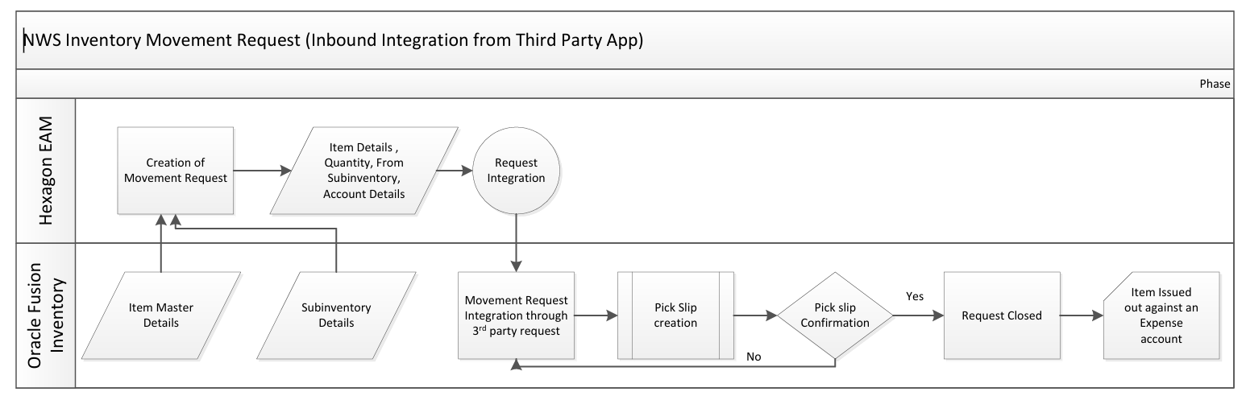
Inbound Flow (Hexagon → Fusion):
1. MR created and approved in Hexagon.
2. Hexagon triggers integration API with payload.
3. Oracle Integration Cloud processes and validates the data.
4. Oracle Fusion creates Material Issue transaction.
5. Acknowledgment sent to Hexagon.
Outbound Flow (Fusion → Hexagon):
1. Scheduled job fetches latest On-Hand and MR Status from Fusion.
2. Data transformed and sent to Hexagon via API.
3. Hexagon updates local data accordingly.
4. Error logs generated for any failed transmissions.

6. Assumptions & Constraints
- Only approved MRs will be transmitted.
- Both systems share consistent Item Master data.
- Sub-inventory and Org details preconfigured in both systems.
- Integration frequency to be finalized based on business needs.
- APIs must comply with Oracle Fusion public REST standards.

7. Risks & Mitigation

Risk | Impact | Mitigation
Data mismatch between systems | Incorrect quantities or duplicates | Enable reconciliation and validation logic
API downtime | Delayed postings | Implement retry queue with monitoring
Invalid Charge Account | Failed Fusion transactions | Pre-validate in Hexagon before submission
High data volume | Performance degradation | Use batch processing mechanisms

Open and Close Issues

8.1 Open Issues
S. No | Issue | Resolution | Responsibility | Target Date | Impact Date
1
2

8.2 Closed Issues
S. No | Issue | Resolution | Responsibility | Target Date | Impact Date
1
2

